Library Management System Report

FY BTECH CSE(AI-DS) DIV-10
FOUNDATION OF PROGRAMMING

👥Group Members
- Rajganesh Reddy – 1262251774
- Pranjal - 1262253585
- Rohan Patil - 1262252816
- Shreyas Bhat - 1262252958
- Sarvesh Shinde – 1262253585
INDEX
S.No | Topic | Page No
1 | Introduction | 3
2 | Objectives | 6
3 | Tools & Technologies | 7
4 | Program Design | 9
5 | Library Management Files | 12
6 | Code Snippet | 14
7 | Sample Output | 23
8 | Conclusion | 27
9 | References | 28

INTRODUCTION
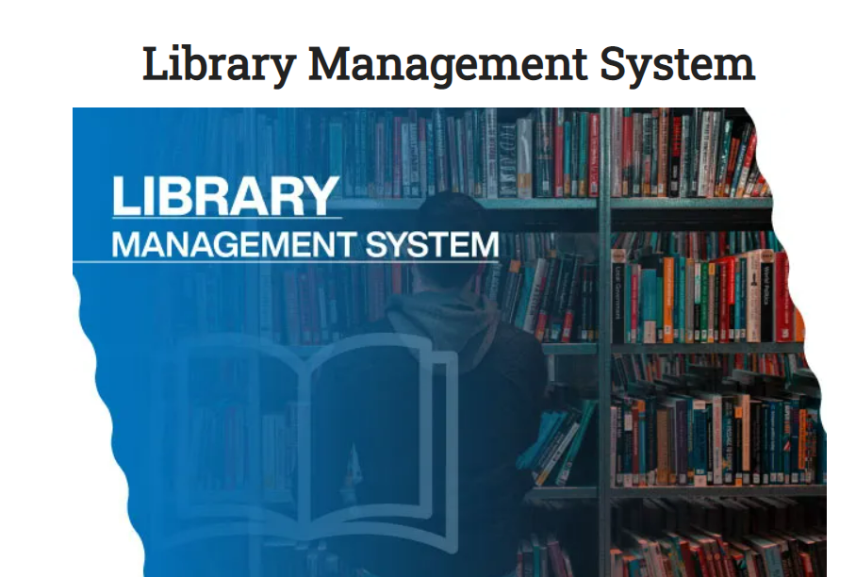

Introduction
A Library Management System is a software application designed to manage and maintain a library’s operations efficiently. In traditional libraries, managing books, recording issued and returned books, and tracking borrowers were done manually. This process is often time-consuming, prone to errors, and difficult to maintain as the library collection grows.
The Library Management System in C automates these tasks, providing a user-friendly platform to store, manage, and retrieve information about books and authors. It allows the librarian to add new books, display all books, search for a particular book, and modify book details. This system ensures accurate record-keeping and reduces the chances of misplacing or losing information.
Importance of the Project
- Efficiency: The system reduces manual work and speeds up operations like adding, searching, or updating book records.
- Data Accuracy: All book records are stored digitally, which reduces errors compared to manual record-keeping.
- Organization: Books can be categorized and tracked easily using the system.
- User-Friendly: Even users with basic computer knowledge can operate the system efficiently.
- Scalability: The system can manage a large number of books without becoming cumbersome.
Scope of the Project
- This system is ideal for school and college libraries, where tracking hundreds of books manually is difficult.
- It provides a foundation for advanced library management systems that may include features like issuing books to students, keeping track of returns, and generating reports.
- The program can also be extended in the future to include GUI interfaces or database integration for more robust operations.
In summary, the Library Management System in C is a simple yet powerful project that demonstrates the use of programming concepts, data structures, and file handling in real-world applications. It makes library operations faster, more accurate, and more reliable.
This system not only helps librarians manage their collection efficiently but also ensures that students or readers can easily access information about available books. By automating routine tasks, it saves time and reduces human error, making library operations more reliable.

OBJECTIVES OF LIBRARY MANAGEMENT SYSTEM
The main objectives of this project are to:
- Maintain Accurate Records: To store details of books such as book name, author, and unique ID in a systematic way.
- Simplify Library Operations: To make tasks like adding, searching, and modifying book records quick and easy.
- Provide Easy Access: To allow librarians and users to quickly search for a book by name or author.
- Reduce Manual Work: To minimize errors and time wasted in manual record-keeping.
- Demonstrate Programming Concepts: To show practical application of C programming, including data structures, functions, and file handling.
- Scalability: To manage a large number of books efficiently, with the possibility of future enhancements like issuing/returning books.
TOOLS AND TECHNOLOGIES USED
For the successful implementation of the Library Management System, several tools and technologies are required. These tools help in writing, compiling, and running the program efficiently, and also provide the necessary features for managing data using file handling and data structures. The following are the main tools and technologies used in this project
- Programming Language: C
  - The project is implemented in the C programming language because it allows structured programming and easy handling of data through structures, arrays, and file operations.
- Compiler / IDE:
  - Code::Blocks / Turbo C / GCC
  - These IDEs provide a user-friendly environment for writing, compiling, and executing C programs.
- Operating System:
  - Windows / Linux
  - The system is compatible with common operating systems used in colleges and schools.
- File Handling:
  - Text or binary files are used to store book records permanently, even after the program closes.
- Data Structures Used:
  - Structures: To store book information like name, author, and ID.
  - Arrays: To manage multiple book records efficiently.
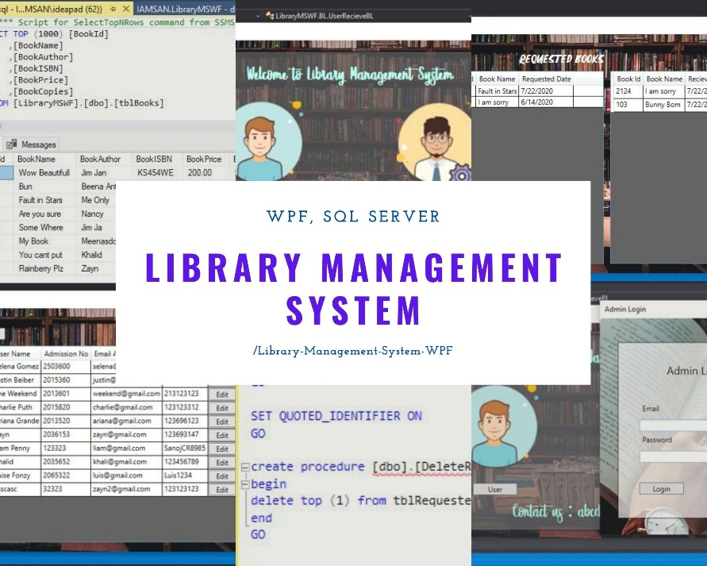
PROGRAM DESIGN USED FOR THIS PROJECT
The Library Management System in C is designed to automate library operations using structured programming, file handling, and modular functions. It allows the librarian to add, delete, search, and issue books, while keeping all data persistent.
1. Data Structures
- struct book – stores book ID, name, author, and date of addition.
- struct issue – stores issued book details: book ID, book name, student name, class, roll number, and issue date.
- Global variables b and s represent a current book and an issued book.
2. Modular Functions
Function | Purpose
addBook() | Adds a new book to books.txt.
booksList() | Displays all books in the library.
del() | Deletes a book by ID.
issueBook() | Issues a book to a student and saves in issue.txt.
issueList() | Displays all issued books.
3. Program Flow
- Display menu: Add, Display, Delete, Issue, Issued List, Exit.
- User selects an option → corresponding function executes.
- Program loops back to menu until Exit is chosen.
Flow Diagram (simplified):
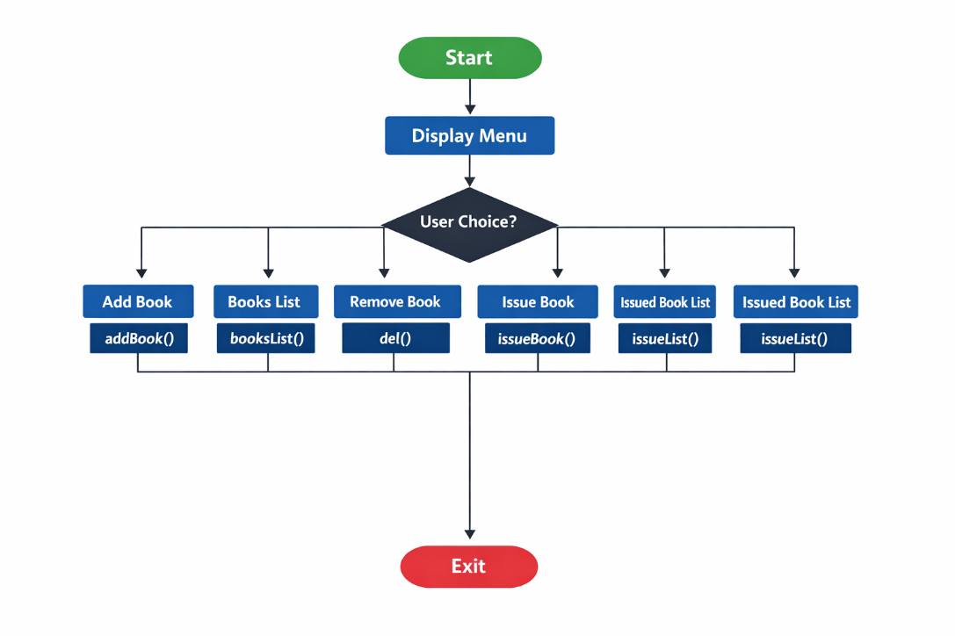
4. Key Features
- Data Persistence: Files ensure records are saved permanently.
- Modular Design: Each function handles a single responsibility.
- User-Friendly: Menu-driven interface simplifies usage.
- Scalable: Can manage multiple books and issued records efficiently.

LIBRARY MANAGEMENT FILES
This project uses two main files to store data permanently:
File Name | Purpose
books.txt | Stores all book records added to the library, including Book ID, Name, Author, and Date of addition.
issue.txt | Stores all issued book records, including Book ID, Book Name, Student Name, Class, Roll Number, and Date of Issue.
Explanation
- books.txt
  - Every time a book is added using addBook(), the details are saved to this file in binary format.
  - When booksList() is called, all records are read from this file and displayed.
  - When del() is called, the file is updated to remove the deleted book.
- issue.txt
  - Every time a book is issued using issueBook(), the student details along with the book information are saved to this file.
  - issueList() reads this file to display all issued books.
Key Points
- Both files ensure data persistence, meaning information is not lost when the program closes.
- Using binary mode (rb, wb, ab) allows efficient reading/writing of records.
- Temporary files (like in the delete function) are used to safely update records without losing data.
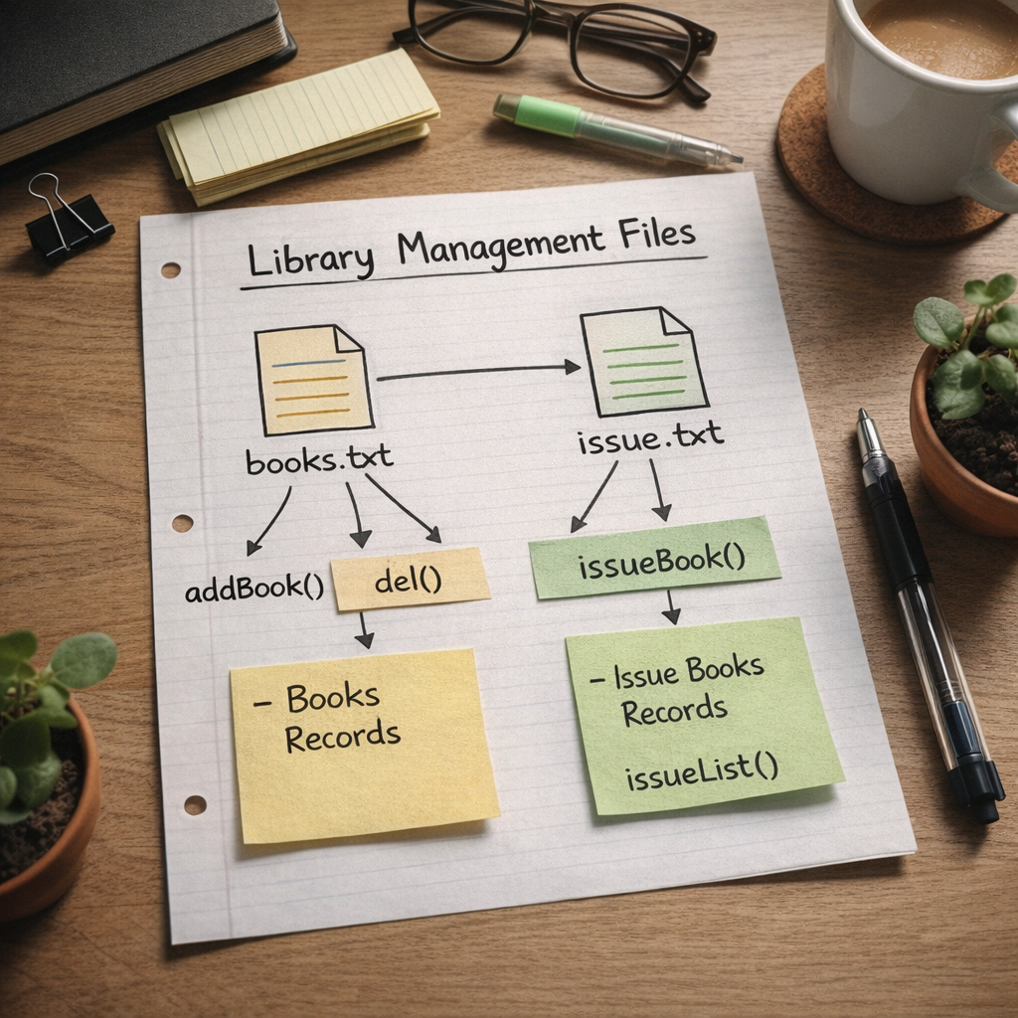
CODE SNIPPET

#include <stdio.h>
#include <stdlib.h>
#include <string.h>
#include <time.h>

/* ---------- Structures ---------- */
struct book {
int id;
char bookName[100];
char authorName[100];
char date[12];
};

struct issue {
int id;
char bookName[100];
char sName[100];
char sClass[50];
int sRoll;
char date[12];
};

/* ---------- Global Variables ---------- */
struct book b;
struct issue s;
FILE *fp;

/* ---------- Function Declarations ---------- */
void addBook();
void booksList();
void del();
void issueBook();
void issueList();

/* ---------- Main Function ---------- */
int main() {
int ch;

while (1) {
printf("\n<== Library Management System ==>\n");
printf("1. Add Book\n");
printf("2. Books List\n");
printf("3. Remove Book\n");
printf("4. Issue Book\n");
printf("5. Issued Book List\n");
printf("0. Exit\n");
printf("Enter your choice: ");
if (scanf("%d", &ch) != 1) {
printf("Invalid input!\n");
exit(1);
}
getchar(); // consume newline

switch (ch) {
case 0:
exit(0);
case 1:
addBook();
break;
case 2:
booksList();
break;
case 3:
del();
break;
case 4:
issueBook();
break;
case 5:
issueList();
break;
default:
printf("Invalid Choice!\n");
}
}
return 0;
}

/* ---------- Add Book ---------- */
void addBook() {
char myDate[12];
time_t t = time(NULL);
struct tm tm = *localtime(&t);

sprintf(myDate, "%02d/%02d/%d",
tm.tm_mday, tm.tm_mon + 1, tm.tm_year + 1900);
strcpy(b.date, myDate);

fp = fopen("books.txt", "ab");
if (fp == NULL) {
printf("File error!\n");
return;
}

printf("Enter Book ID: ");
scanf("%d", &b.id);
getchar();

printf("Enter Book Name: ");
fgets(b.bookName, sizeof(b.bookName), stdin);
b.bookName[strcspn(b.bookName, "\n")] = 0;

printf("Enter Author Name: ");
fgets(b.authorName, sizeof(b.authorName), stdin);
b.authorName[strcspn(b.authorName, "\n")] = 0;

fwrite(&b, sizeof(b), 1, fp);
fclose(fp);

printf("Book Added Successfully!\n");
}

/* ---------- Books List ---------- */
void booksList() {
printf("\n<== Available Books ==>\n\n");
printf("%-10s %-30s %-30s %s\n",
"ID", "Book Name", "Author", "Date");

fp = fopen("books.txt", "rb");
if (fp == NULL) {
printf("No books found!\n");
return;
}

while (fread(&b, sizeof(b), 1, fp)) {
printf("%-10d %-30s %-30s %s\n",
b.id, b.bookName, b.authorName, b.date);
}
fclose(fp);
}

/* ---------- Delete Book ---------- */
void del() {
int id, found = 0;
FILE *ft;

printf("Enter Book ID to delete: ");
scanf("%d", &id);

fp = fopen("books.txt", "rb");
if (fp == NULL) {
printf("No books file found!\n");
return;
}
ft = fopen("temp.txt", "wb");
if (ft == NULL) {
printf("Temporary file error!\n");
fclose(fp);
return;
}

while (fread(&b, sizeof(b), 1, fp)) {
if (b.id == id) {
found = 1;
} else {
fwrite(&b, sizeof(b), 1, ft);
}
}

fclose(fp);
fclose(ft);

remove("books.txt");
rename("temp.txt", "books.txt");

if (found)
printf("Book Deleted Successfully!\n");
else
printf("Book Not Found!\n");
}

/* ---------- Issue Book ---------- */
void issueBook() {
int found = 0;
char myDate[12];

time_t t = time(NULL);
struct tm tm = *localtime(&t);
sprintf(myDate, "%02d/%02d/%d",
tm.tm_mday, tm.tm_mon + 1, tm.tm_year + 1900);
strcpy(s.date, myDate);

printf("Enter Book ID to issue: ");
scanf("%d", &s.id);
getchar();

fp = fopen("books.txt", "rb");
if (fp == NULL) {
printf("No books file found!\n");
return;
}

while (fread(&b, sizeof(b), 1, fp)) {
if (b.id == s.id) {
strcpy(s.bookName, b.bookName);
found = 1;
break;
}
}
fclose(fp);

if (!found) {
printf("Book not found!\n");
return;
}

fp = fopen("issue.txt", "ab");
if (fp == NULL) {
printf("Issue file error!\n");
return;
}

printf("Enter Student Name: ");
fgets(s.sName, sizeof(s.sName), stdin);
s.sName[strcspn(s.sName, "\n")] = 0;

printf("Enter Student Class: ");
fgets(s.sClass, sizeof(s.sClass), stdin);
s.sClass[strcspn(s.sClass, "\n")] = 0;

printf("Enter Student Roll: ");
scanf("%d", &s.sRoll);

fwrite(&s, sizeof(s), 1, fp);
fclose(fp);

printf("Book Issued Successfully!\n");
}

/* ---------- Issued Book List ---------- */
void issueList() {
printf("\n<== Issued Books ==>\n\n");
printf("%-10s %-20s %-15s %-10s %-30s %s\n",
"ID", "Student", "Class", "Roll", "Book", "Date");

fp = fopen("issue.txt", "rb");
if (fp == NULL) {
printf("No issued books!\n");
return;
}

while (fread(&s, sizeof(s), 1, fp)) {
printf("%-10d %-20s %-15s %-10d %-30s %s\n",
s.id, s.sName, s.sClass, s.sRoll, s.bookName, s.date);
}
fclose(fp);
}

SAMPLE OUTPUT
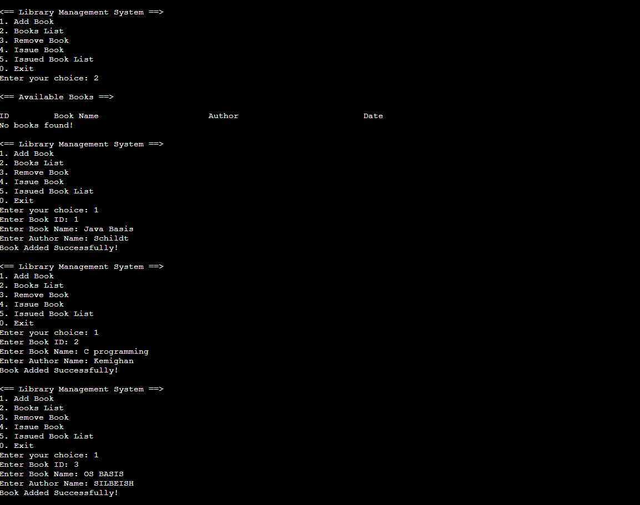
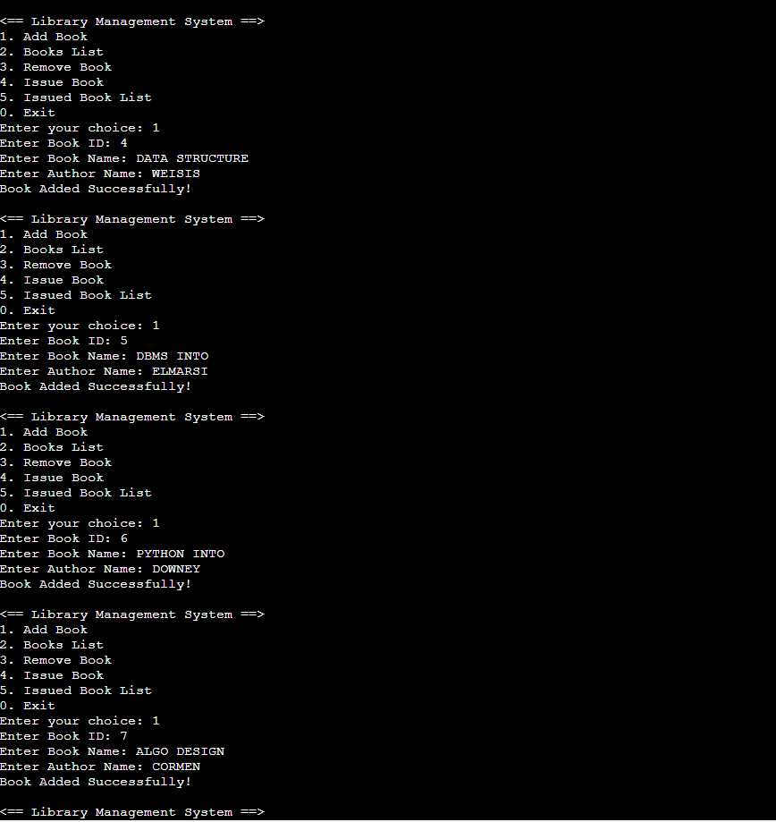
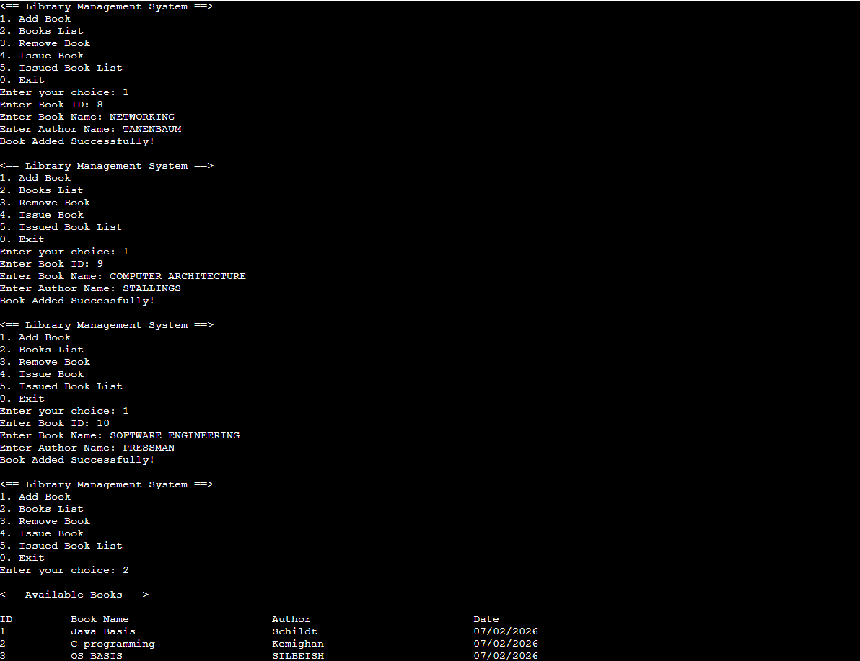
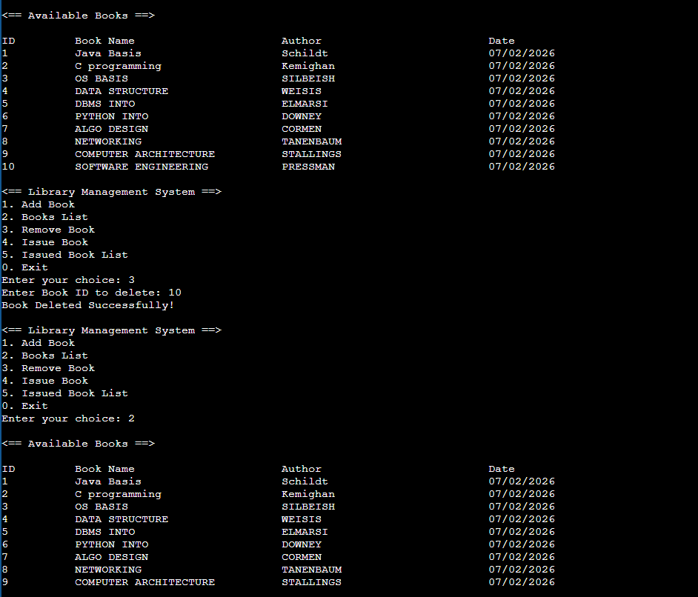
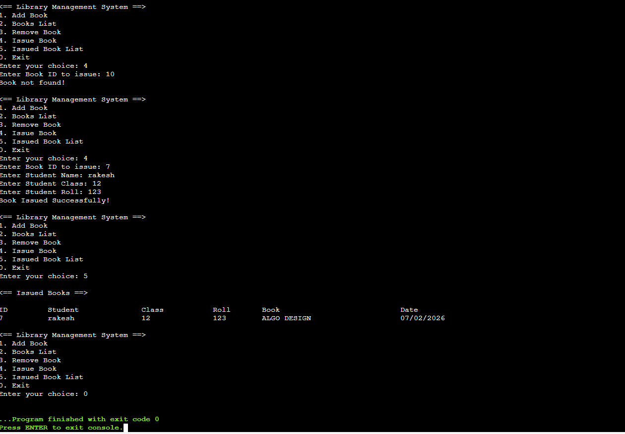
CONCLUSION
Conclusion
The Library Management System in C successfully automates the management of books and issued records in a library. It allows users to add, delete, search, and issue books efficiently while maintaining all records permanently using files.
The project demonstrates the use of structured programming, modular functions, and data structures such as structures and arrays. Its menu-driven interface makes it simple and user-friendly for librarians and students alike.
By automating routine tasks, the system reduces manual errors, saves time, and organizes records systematically. In the future, it can be enhanced with GUI, database integration, or additional features to make library management even more efficient.

REFERENCES
1. The C Programming Language – Brian W. Kernighan, Dennis M. Ritchie
2. Let Us C – Yashavant Kanetkar
3. Programming in C – E. Balagurusamy




